FOUNDATION FOR VIRTUAL AND AUGMENTED REALITY SYSTEMS
Lecture39
Lec-39: System Design
Hello and welcome to the NPTEL MOOCs course on Foundations for Virtual and Augmented Reality Systems. So we are discussing the design part, design of immersive experiences. We started our discussion in the previous part of the lecture and we will continue with that discussion. So earlier what we have covered, let us quickly and briefly recap. So we started our discussion on the design part.
And talked about the design guidelines. So, we covered a set of generic guidelines and also started discussing the interaction techniques. So, when we are talking about the design of experience, certainly interaction plays a very important role in that design, and there are different techniques that are typically followed when we are talking about immersive experience. So, we are discussing those techniques.
We just started with a brief introduction to those techniques and we will continue our discussion on interaction techniques in this part of the lecture as well. So, if you recollect, we mentioned different types of interaction. Broadly, there are three categories. Object interaction, so we are interacting with virtual objects in the immersive virtual world. Then navigation that is moving from one point in the virtual world to another point and corresponding change in viewpoint.
Here, mostly the object interaction is not involved. However, in some navigation techniques, object interaction may be required as we shall see in our subsequent discussion. And thirdly, the more regular type of interaction that is interaction for system control. So here what happens is that we perform certain interactions to set up the system, to initialize certain parameters, to provide initial information to the system and so on. This is more like setting up of options, menus and so on.
And these interactions are mostly of a regular type, Unlike the object manipulation, object interaction and navigation types of interactions. So, let us start our discussion with object interaction techniques. Now, object interactions can be broadly of two types. So, there are broadly two ways to interact with objects.
One is interaction for selection. So, here what happens is that we select the object with which we want to interact and the second part is the manipulation, interaction for manipulation. So, once the selection is done, we interact with the object which is typically called manipulation of the object which changes the object properties. So, broadly these two types of interactions with objects
are there in any virtual experience. For each of these interactions, we mostly have separate types of interaction techniques. So, let us discuss them separately. Let us start with object selection techniques. Now, when we talk about selection, it essentially refers to the selection or specification,
specifying one or more objects from a set of objects, typically the set of virtual objects that are part of the virtual world. Now, when we talk of interactions for selection of objects, How do we know which kind of interaction is suitable for a given virtual experience? So, that is determined by a set of parameters or variables which influence the user performance while accomplishing the selection task. Now, what are these parameters?
Distance of the object to be selected from the current viewpoint. or camera position, then the direction of the object to be selected, size of the object, density of objects around the target, that means whether the object to be selected is a standalone object or it is surrounded by other objects and how densely, the surrounding objects are placed around the object to be selected or objects to be selected. This is also an important parameter that decides the performance of selection.
Number of targets to be selected, number of objects to be selected and so on. So, these are some of the parameters, the most important parameters, that determine what kind of selection techniques to be used in a given context, so that the performance is maximized. Also, sometimes target occlusion can play an important role in selection performance. If a target is partly occluded by other surrounding objects, then locating and selecting the target is a challenging task and specialized techniques may be required to let the user select
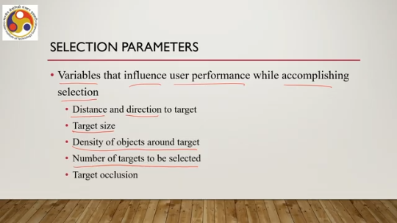
partially occluded objects. Sometimes even fully occluded objects may also be selected. However, it is important to note that when an object is fully occluded, first of all, the user needs to be made aware of its presence. Otherwise, since it is not visible, the user will not know that there is an object which may be of importance and needs to be selected. So, specialized techniques may be used,
For selection of fully occluded objects, but those are special cases. In the majority of cases, we deal with partially occluded or partially visible objects. So these are the parameters. Now let us quickly recap, quickly go through the techniques, different selection techniques. We can have selection with hand.
That is our hand we can use for selection of objects in a virtual world. Then we can have pointing-based selection, selection with hand then pointing-based selection, then image plane selection is another selection technique, volume-based selection is yet another technique, and bimanual selection can be another technique. So, we have different ways. Different methods to select objects in a virtual world and the suitability of a particular method depends on the selection parameters which we have discussed in the previous slide.
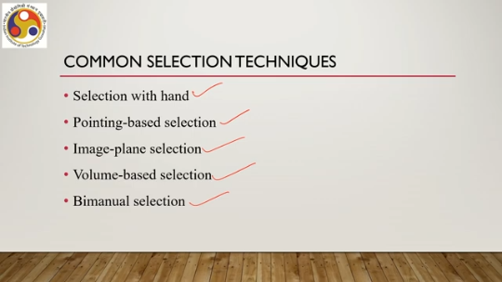
So, what are the, what is hand selection technique and what are the different techniques under this category of selection? Let us go through those techniques. Now as the name suggests when we say hand selection techniques essentially it means selection of objects virtual objects in the virtual world with the hand. So, essentially whenever we are selecting something with our hand then that is that falls under this category. It may be noted that conventionally selection with hand refers to selection of objects with a single hand or
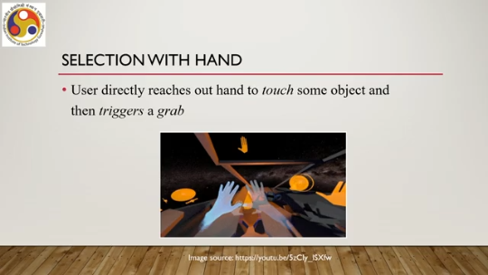
single finger or multiple fingers of a single hand. So, essentially one hand is involved when we talk of selection with hand that is conventional meaning. Now, in this case selection with hand user directly reaches out his or her hand to touch virtually touch some object and then triggers a grab essentially that means selecting the object. So, the most simple intuitive hand selection technique is with the help of a virtual hand.
So, that is essentially you can think of it as an avatar of the physical hand which is visible in the virtual world. Now, here what happens is that there is a direct mapping one to one mapping of users hand motion to a virtual hands motion. So, there is a virtual hand, which is tied to the user's physical hand. Essentially, this comes under tracked hand motion using tracked controllers.
So, when the hand, the physical hand, moves in the physical world, the corresponding virtual hand moves in the virtual world and these two movements are exactly the same. So, earlier we have seen when we discussed hardware that there can be 3D tracked controllers. So, those are typically used to implement this type of virtual hand which has one-to-one mapping to the physical hand. So, virtual hand orientation is directly mapped to the input device or real hand orientation and it is most intuitive.
Clearly, I can make natural hand movements to do selection in the virtual world with the virtual hand. However, there is one problem: the problem in selecting objects located further away. When the object is far away, then moving my hand to select a distant object may require a long duration of hand movement, physical hand movement, which may be tiring and which may be annoying.
So, there has to be some other techniques, maybe employment of a travel technique, traveling of hand, a more efficient traveling technique rather than the intuitive one, so that this tiring effort is reduced. One way to overcome this problem, that is selection of distant objects without feeling tired, is the go-go technique. It allows the user to interactively change the virtual arm length, that is the length of the virtual hand. There is one-to-one mapping when the target is closer to the user.
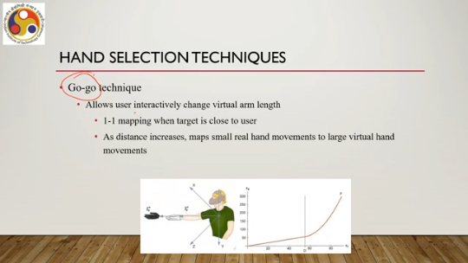
The regular hand selection takes place when the target is close. However, as the distance increases, the technique maps smaller real hand movements to larger virtual hand movements. So, what happens is that initially, if you see here, this is the speed of the movement and this is the time. So, initially the As the distance of the object is nearer, there is one-to-one mapping.
As the distance increases, there may be exponential change in the way the hand moves. The further the distance is, the larger the hand movement is compared to the physical hand movement. So, the physical hand may move a little, but the virtual hand may move far away with higher speed so that the distant objects can be reached quickly and selected. So, this is one way to overcome distant object selection with virtual hand movement through this go-go technique.
However, the problem is precision. So, low precision problem is there for distant small object selection because the hand moves faster when the object is further away. Now, if the object is small, the faster movement due to the faster movement of the hand, the hand may miss the object and may bypass the object or may cross the object, and it is difficult to control such movements.
That is one problem when we have to select distant small objects. Another technique An improvement of the go-go technique is called prism. It applies scaled-down motion to the virtual hand when the user's hand is moving below a specified speed. So, depending on the speed, we can control the movement.
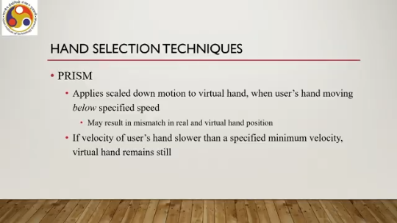
Of course, it may result in a mismatch in the real and virtual hand position that is there in the go-go technique as well. Because here there is no one-to-one mapping. So, there may be a mismatch which may be counterintuitive. However, for selection of distant objects, this may provide a better solution compared to the go-go technique because here we can control the movement by reducing the physical hand movement speed. If the velocity of the user's hand is slower than a specified minimum velocity, the virtual hand remains still.
That means if we reach closer to a distant object and we reduce the speed of our hand, then the movement of the virtual hand slows down. And if we stop our physical hand, then it stops there so that it is easier to select the object. This particular feature is not there in the go-go technique. The other hand selection technique is called intent-driven selection. In the previous cases, be it regular virtual hand movement or go-go or prism, we are physically moving the hand to select it.
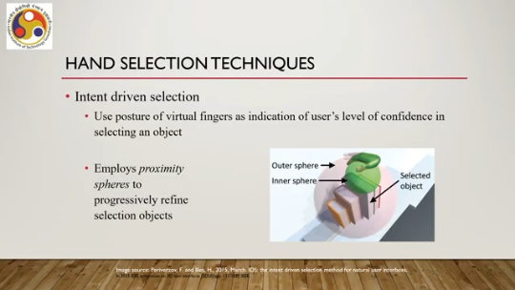
Now, and there we are providing some gestures, but these gestures can be provided in a different way to select. An object. So, the user positions their virtual fingers or the user uses the posture of the virtual fingers as an indication of the user's level of confidence in selecting an object. So, if we are trying to select an object, we will move our virtual hand towards that object and maybe put a particular posture of our fingers around the object to indicate that we want to select that object.
Now, typically such techniques employ proximity spheres to progressively refine the selection of the object. For example, here as you can see, when we put our finger around this zone, this entire A bigger sphere is there. This sphere encompasses multiple objects. But then, as we move closer to the intended object,
the spheres progressively reduce in size and come to a more specific object so that it is easier to indicate which one I want to select given a set of surrounding objects. So, this is the progressive refinement, progressive refinement of the surrounding sphere or proximity sphere depending on hand postures, finger postures. So, we can say that this intent-driven selection may be followed by hand movement either through go-go or prism technique. We can combine these two. So go-go or prism is essentially a travel technique whereas this intent-driven selection is the grabbing technique.
Next is pointing-based selection. So far we have discussed selection with hand. Now let us move our attention to the second category of selection techniques, that is, pointing-based selection. Now, in the case of pointing-based selection, what happens is that the user extends a ray into the distance in the virtual world.
As shown here, this is the user. Through operation of a controller in the virtual world, the user gets to see a ray extending into the distance. And the first object that is intersected by the ray can then be selected via a user-controlled trigger, which is part of the controlling device or controller device. So, essentially you are using a ray to indicate that I want to select a particular object.
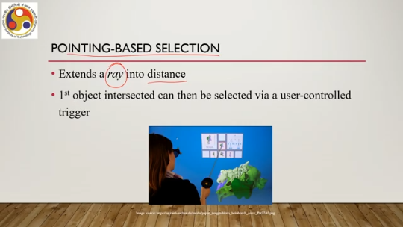
Now, there are different ways in which the pointing can be done. The obvious one is hand pointing. which the previous figure has shown. Here, pointing is done using the hand or handheld input devices, typically handheld input devices. But apart from hand pointing, there can be other types of pointing as well.
Say, for example, head pointing. Here, the pointing is done using head movement. So, the ray extends from the head position into the distance, and as we move the head in the virtual world, corresponding ray moves so that we can select. So, there we do not need our hand to extend the ray and select an object.
Similarly, we can have eye gaze pointing as well, where we are extending the ray using eye gaze controlling devices or eye trackers, and with the change in eye gaze we can change the pointing as well. So, either we can use our hand with some handheld controllers to extend the ray or, using head-mounted displays, we can directly use it to extend the ray and control it by head movements or we can use an eye tracker device to track our eye gaze and accordingly we can extend the ray into the distance using the eye gaze.
Now, that is about different body parts that we can use to extend and control the ray for selection. Other thing is different ways to extend the ray. We can have the most basic techniques called ray casting. Here, the user points at objects with a virtual ray, which is typically what we have seen in the first case, first image.
Now a virtual ray is nothing but a short line segment or infinite line, either way it is possible. The virtual ray can be attached directly to the virtual hand or head or eye depending on the device we are using. In case the hand cannot be tracked, head position can be used or eye gaze can be tracked, as we have seen. Some use gaze pointing to estimate the target and trigger selection with hand pointing. So, a combination of gaze pointing and hand pointing both are used.
Like hand-based selection, here also selecting small objects located far away can be difficult because it requires precision. So, precisely pointing the ray towards a distant small object is quite challenging, requires some practice, and the problem gets compounded when the small object is surrounded by other objects smaller or larger, or of similar size. So, in that case, precisely pointing to the object to be selected becomes challenging.
Now, to alleviate that problem, there are improvements done to the basic ray casting method. One such improvement is bend cast. In this technique, the system bends the ray towards the object closest to the path. The closest object is detected by calculating point-line distance from each selectable object. So, essentially we need to identify while extending a ray which are the closest objects and we have to cast the ray in a way such that the closest object,
the object that we want to select is the closest among all the objects around the path of the ray. So, there we do not need to precisely point to the object, but we can point the ray closest to the object. So, the precision problem is reduced, and once the closest object is determined, a circular arc can be used to provide visual feedback for bending. So, essentially after detection of the closest object, the system can tell that this way the object can be selected. So, this is one improvement, but this technique works best when only a few objects are located near the pointing vector's path or the ray's path.
If there are a large number of objects, then it is very difficult to cast the ray such that the object to be selected becomes closest; there can be multiple. Objects around the other objects and the distances may be similar. So, all may become closest or some different object may become closest if the density around the object to be selected is high. So, again the precision problem comes. Another improvement is depth ray, an improvement over the basic ray casting method, is the depth ray technique.
Through this technique, we can disambiguate between objects the user intends to select when the pointing vector hits multiple targets. So, if there are multiple objects around the object to be selected and by mistake we have cast a ray that crosses multiple objects, which one we want to select is difficult to pinpoint, but using this technique, the depth ray technique, we can do so. At the time of selection, the object closest to the depth marker and intersected by the pointing vector is selected. So, there is an additional aid used called the depth marker to do the disambiguation, and the user can control the position of the depth marker by moving the hand forwards or backwards.
Essentially, it is an indirect way of indicating to the system that the object I want to select is closest to the marker that is positioned around the set of objects. And based on that depth marker position, the object is selected. So, in the depth ray technique, we use additional aid along with the ray cast, along with the ray that is cast, which is called the depth marker. Now, those are some of the pointing-based techniques, major techniques.
The third category of selection techniques are the image plane or volumetric selections. Let us first talk about the image plane selection. It is also known as occlusion and framing. So, the idea is shown here in this figure. The user holds one or two hands between the eye and the desired object.
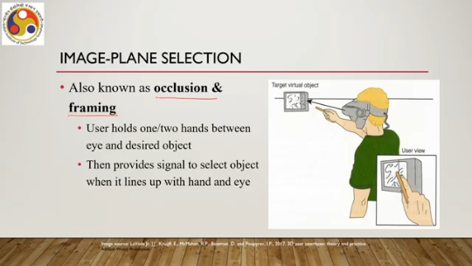
So, here the eye position is shown, the desired object is here, and the user is holding the hand between the eye position and desired object. Then, the user provides a signal, maybe in the form of a gesture, to select the object when it lines up with the hand and eye. So, this hand movement or hand signal is the kind of signal. It can be through some gesture also.
So, in the virtual world, the user provides a signal to indicate which one to select. So, there are several such techniques. One is the head crusher technique as shown here. The user positions the thumb and the forefinger in a way around the desired object such that the object is enclosed using the thumb and forefinger as shown here. Suppose this is the user and this is the virtual object in the virtual world as seen by the user.
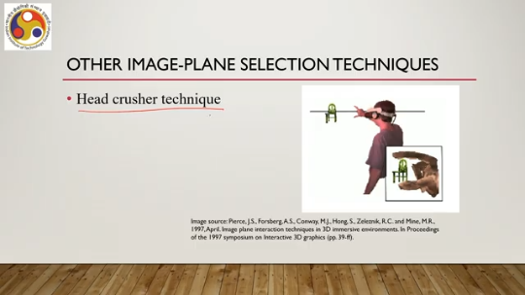
Now the user positions the thumb and forefinger here. In a way such that the forefinger and the thumb indicate the object or surround the object in this 2D image plane. This is called the head crusher technique. Then we have other techniques as well. One such is the sticky finger technique.
Here the object underneath the user's finger is selected. Then we have the lifting palm technique. The user selects objects by flattening their outstretched hand and positioning the palm so that it appears to lie below the desired object as if the user is trying to lift the object with the palm. Also, we have the framing hands technique. Hands are positioned to form the two corners of a frame in the 2D image surrounding an object, typically seen while capturing movies or such visual media.
So, framing hand techniques are more common; sticky finger, lifting palm or the head crusher techniques less so. Now, previous techniques. Assume that the user is trying to select on a 2D view plane. Essentially, the view plane contains the object as viewed by the user from a distance and the user defines the view plane as the plane holding the object and then uses the fingers or hands to pinpoint the object.
That is a 2D selection or image plane selection. Similarly, The idea can be extended for volumetric selection where it enables the user to select a 3D region in space, that is the virtual space, and corresponding objects within that space get selected. Now the region can be in the form of a box or cube, sphere or cone. Some of these techniques include the cone casting flashlight technique, which extends the ray casting idea. Here, instead of a ray, a cone is used.
So a cone is cast to a distance, and objects within the cone get selected. So, since the cone is volumetric, multiple objects may come within its extent, and those objects get selected. The problem is selection of small objects or tightly grouped objects may be difficult. So, when we cast a cone, since it is essentially volumetric, it encapsulates multiple objects.
Now, if we want to select smaller, fewer objects, then that becomes difficult. Another technique is the sphere casting flashlight technique. The earlier one is cone casting; this is sphere casting. So, we cast a sphere onto the nearest intersected surface, and the objects found within the sphere are selected. That is the second volumetric selection technique.
Then we can have the two-handed box selection technique. where the user can use both hands to position, orient, and shape a box or a cube; maybe a rectangular-shaped box also, a rectangular parallelepiped can also be selected, but mostly it is a cube. For example, this virtual avatar is used to depict how both hands can be used to first define a box. shown with this blue line and how that can progressively be reduced with other boxes shown with this white line to basically select a specified region of the 3D space. These types of techniques, volumetric selections, it may be obvious that these types of techniques are most useful when we are trying to select
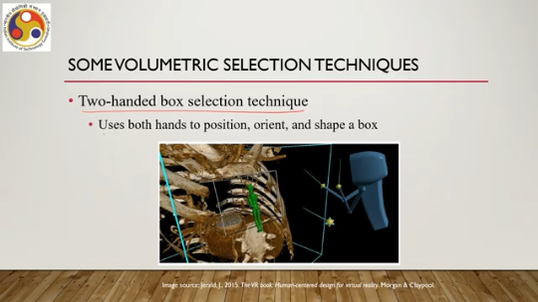
small or well-defined isolated objects in a less complex virtual environment. If the virtual environment is quite complex with a lot of objects, then selection of smaller objects will be problematic with any of the volumetric selection techniques. Now, these two-handed volumetric selection techniques can also be called bimanual selection where both hands are used. That is about object selection. Once the object is selected, the next thing we do is basically manipulation of the object.
So, there are different ways to manipulate objects. In manipulation, what we do is we modify the object properties. such as position, orientation, scale, shape, color, texture, behavior even and so on. So these properties such as position, orientation, scale, shape, color, texture, behavior and others are essentially what we try to change when we refer to manipulation techniques. As is obvious, it typically follows selection.
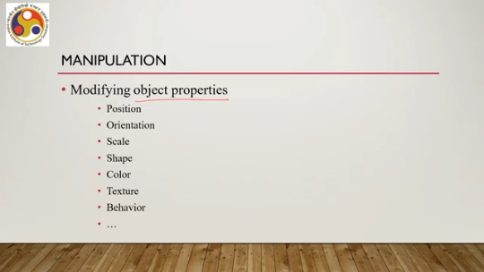
After selection, we are supposed to do some manipulation. Now, there are several manipulation techniques available. One is hand manipulation like hand-based selection. Then indirect manipulation is there. Bimanual manipulation is there.
And integrated hybrid manipulation is also there. Let us start with the hand manipulation technique. So the same virtual hand idea is extended here and using the virtual hand we manipulate objects. It follows hand selection, smart gloves or gesture-based manipulation or controller-based interaction are implemented to do the manipulation and it is the most intuitive way of manipulating objects. Now, hand manipulation requires a little bit more computational power or specialized devices which may be relatively costly to reduce cost or for other factors.
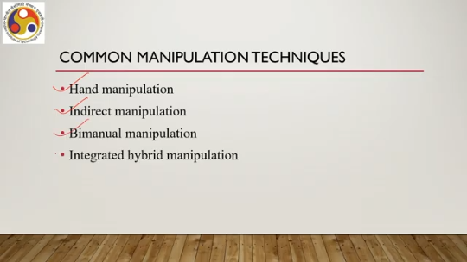
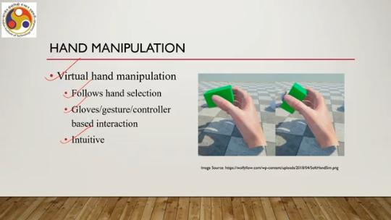
We can sometimes have indirect manipulation where we are not directly manipulating using our physical hand. Instead, we are manipulating some other objects which in turn are manipulating the desired object. So, these other objects are mapped to the desired virtual object and by manipulating the other objects, we are essentially manipulating the desired objects. This is called indirect manipulation.
It allows users to manipulate virtual objects without directly interacting with the virtual object. Instead, the user interacts with some other objects that are mapped to the virtual objects. A simple way of doing this is using the 3D widgets. So, we are already familiar with such widgets. For example, if I want to scroll up or down a page, I can directly do so or I can use a scroll bar to do so.
Now, usage of a scroll bar is essentially an indirect way of manipulating the interface. So, here I am not directly moving the page up or down; instead I am moving the scroll bar up and down and correspondingly the page is moving up and down. So, that is an example of a 2D widget. Similarly, we can have 3D widgets in the virtual world by manipulating the 3D widgets; widgets and handles are there to put controls directly in the 3D scene with the objects.
Typically, each widget is responsible for only a small set of manipulation degrees of freedom. So, for a given object, a single widget may not be sufficient to manipulate all properties. Instead, for a specified set of degrees of freedom can be manipulated using 3D widgets, using each widget. Another indirect manipulation technique is through the use of indirect proxies. It allows users a more natural grasping method to perform direct manipulation through local proxies.
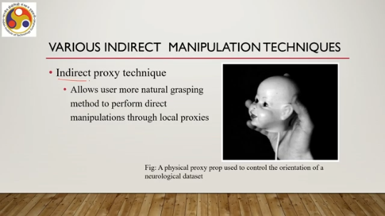
For example, this physical proxy prop is used to control the orientation of a neurological data set. Now this data set is linked to the physical prop and if I move the prop then the data set also moves in the virtual world. So, this is another way of doing the manipulation. The third technique is world in miniature, which is another type of indirect proxy.
So, essentially this WIM or world in miniature provides the user a miniature handheld model of the virtual environment, And the user can indirectly manipulate virtual objects by interacting with the representation of those objects in the WIM. So, we have a model of the virtual world which represents all objects in the virtual world. Now, if I manipulate the object in this miniature world, then the actual object in the virtual world gets manipulated. So, that is the idea.
It allows manipulation both within and outside of the user's reach. So, for distant object manipulation, we do not need to select it. Instead, we can manipulate it in the model and then it gets manipulated in the distance. That is the advantage. However, creating such a model for large and complex virtual environments is,
obviously very difficult and in that case implementation of this idea for such large and complex virtual environments is not very practical. Then we have the bimanual manipulation technique. In this case, we manipulate objects with both hands. But the hand manipulation can be synchronous, that is, both hands are moving together, or asynchronous, that is, it is not necessary to move the hands together simultaneously. One bimanual manipulation technique is called spindle, so it is a symmetric synchronous bimanual technique where the hands are positioned symmetrically and they move simultaneously to
perform the manipulation. Two 6 degrees-of-freedom handheld controllers are used to define a virtual spindle. So, we require two controllers and the controllers are symmetrically placed around an imaginary axis on both sides of the imaginary axis, and they move simultaneously; we have to move our hands simultaneously with the controllers so that virtual world objects can be manipulated. To move an object, both hands move in unison or simultaneously; it can also be used to simultaneously rotate the object.
So, both are possible. However, using this technique is not very easy because it has to be synchronous. Now, having synchronous hand movement while interacting in a virtual world is not necessarily a very easy thing for everybody. It requires practice, a lot of practice to use efficiently. A similar technique is spindle plus wheel.
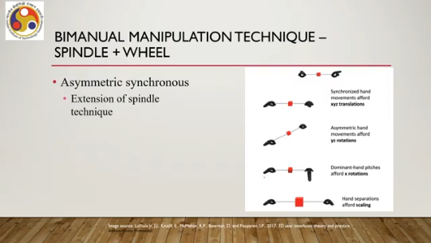
This is an asymmetric but synchronous technique. an extension of the spindle technique. Here also, both hands need to be moved together. However, they need not be symmetrically placed around the sides of the imaginary axis. Finally, we have an integrated hybrid manipulation technique.
These are techniques that switch from selection to manipulation techniques after selection automatically without any explicit signal from the user and switch back to selection mode after manipulation. One such technique is called HOMER which stands for Hand-Centered Object Manipulation Extending Ray Casting. Now in this technique, what happens is that the user selects an object using a ray casting technique then instead of the object being attached to the ray, the user's virtual hand instantly moves and attaches to it.
So, in the previous cases, when we were discussing selection, we said that when we cast a ray, the ray gets attached to the object. In this case, that is not what happens. Instead, once the ray intersects the desired object, the virtual hand of the user moves automatically towards that object and gets attached to the object. Then the technique switches to manipulation mode, that is, allowing the user to change the object properties including position and orientation.
So it allows the user to change the position as well as to rotate the object through hand manipulation. So, here two techniques are mixed: one is ray casting, pointing-based selection, and hand manipulation, manipulation by hand. And also the selection and manipulation are integrated together; the user does not need to do them separately. This is a quite useful technique and an example is shown in this illustration. Suppose this is the virtual object, this kettle, and the user wants to select and manipulate this kettle.
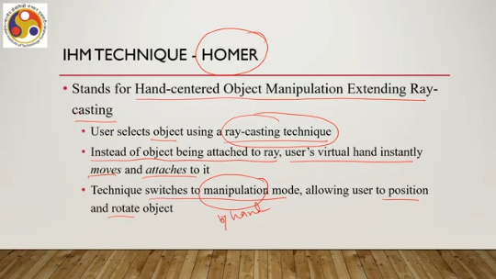
So, once the ray is cast and it intersects the kettle, the hand, the virtual hand, starts moving towards the kettle and then gets attached to it. Then the user performs the manipulation. And after that, the manipulation is over, either through some trigger or some specific hand gesture. The user can indicate to the system that the manipulation job is done. Then it comes back to its original position.
That is the Homer technique. So, we have come to the end of this part of the lecture. With the discussion on Homer, we have come to the end. So let us just summarize before we close this part of the lecture what we have learned. So here we continued our discussion on the interaction techniques that are typically done in immersive environments.
Note that earlier we talked about virtual reality systems and augmented reality systems. However, in the case of augmented reality systems, since our senses are not blocked, regular interaction techniques can be used to interact with the virtual augmentation of the real world. However, in the case of an immersive environment, our senses are blocked. We are cut off from the real world in the ideal case.
And to give us a more or better immersive experience, we need to devise improved interaction techniques. So, we are discussing such techniques. We have covered two types of interaction techniques, that is, object selection and object manipulation. Both are related to virtual objects. The other interaction technique that we need to discuss is navigation techniques, that is, moving from one point to another in the virtual world.
Of course, there is this third category of interaction for system control, which primarily relies on regular interaction techniques that we are familiar with when dealing with any computer system. So with that, we have come to the end of this part of the lecture. I hope you could follow the ideas and you could enjoy the topics. Looking forward to meeting you in the next lecture.
Thank you, goodbye and happy learning.

